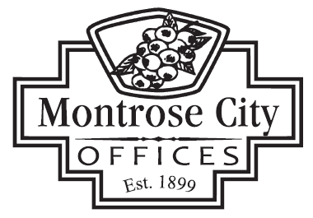

139 S. SAGINAW STREET MONTROSE, MI 48457 / PHONE (810) 639-6168

DOWNTOWN DEVELOPMENT AUTHORITY BOARD (D.D.A.)
November 20, 2025 @ 7:30 a.m.

CALL TO ORDER
ROLL CALL
PLEDGE OF ALLEGIANCE
APPROVAL OF AGENDA
CITIZEN COMMENTS
The purpose of this agenda item is to allow persons to comment. This is not a forum for debate or for which questions will be answered. The Board will consider all comments and questions and decide if they wish to address those items during board comments. All persons addressing the DDA Board are asked to limit their comments to no more than three (3) minutes.

CONSENT AGENDA
- Approval of August 21, 2025, D.D.A. Meeting Minutes
- Approval of October 16, 2025, D.D.A. Meeting Minutes

PRESENTATION
Samantha Mariuz, EDFP Fleis & Vanderbrink – Alignment Report

OLD BUSINESS
- Update from Board Member Coetta Adams on Street Lighting
- Handicap Grant Update – 295 East State Street
NEW BUSINESS
- Consider DDA Function, MCL Act, Community & Marketing Development
- Consider M-57 Communications with MDOT
- Consider DDA Community/Marketing Events

BID AWARD/PURCHASE
- Consider Winter Decorations for Central Business District (CBD)

ORDINANCES

APPOINTMENTS

CITIZEN COMMENTS
The purpose of this agenda item is to allow persons to comment. This is not a forum for debate or for which questions will be answered. The Board will consider all comments and questions and decide if they wish to address those items during board comments. All persons addressing the DDA Board are asked to limit their comments to no more than three (3) minutes.

DDA COMMITTEE REPORTS

CITY MANAGER / DDA BOARD MEMBER COMMENTS

ADJOURNMENT

Next DDA Meeting – December 18, 2025 – 7:30 A.M.

